**Balance Control**

**Topics Covered**

• Control enabling logic.

• PID-based balance control.

**Prerequisites**

• Filtering laboratory experiment.

• PD Control laboratory experiment.

• Pendulum Moment of Inertia laboratory experiment.

• Rotary pendulum module is attached to the QUBE-Servo 2.

**1 Background**

Balancing is a common control task. In this experiment we will find control strategies that balance the pendulum in the upright position while maintaining a desired position of the arm. When balancing the system, the pendulum angle *α* is small and balancing can be accomplished with a simple PD controller, as shown in Figure 1.1. If we are further interested in keeping the arm in a desired position, a feedback loop from the arm position will also be introduced. The control law can then be expressed as

*u* = *kp,θ* (*θr − θ*) *− kp,α α − kd,θ θ*˙ *− kd,α α*˙ *,* (1.1)

where *kp,θ* is the arm angle proportional gain, *kp,α* is the pendulum angle proportional gain, *kd,θ* is the arm angle derivative gain, and *kd,α* is the pendulum angle derivative gain. The desired angle of the arm is denoted by *θr* and the reference for the pendulum angle is zero (i.e. upright position).

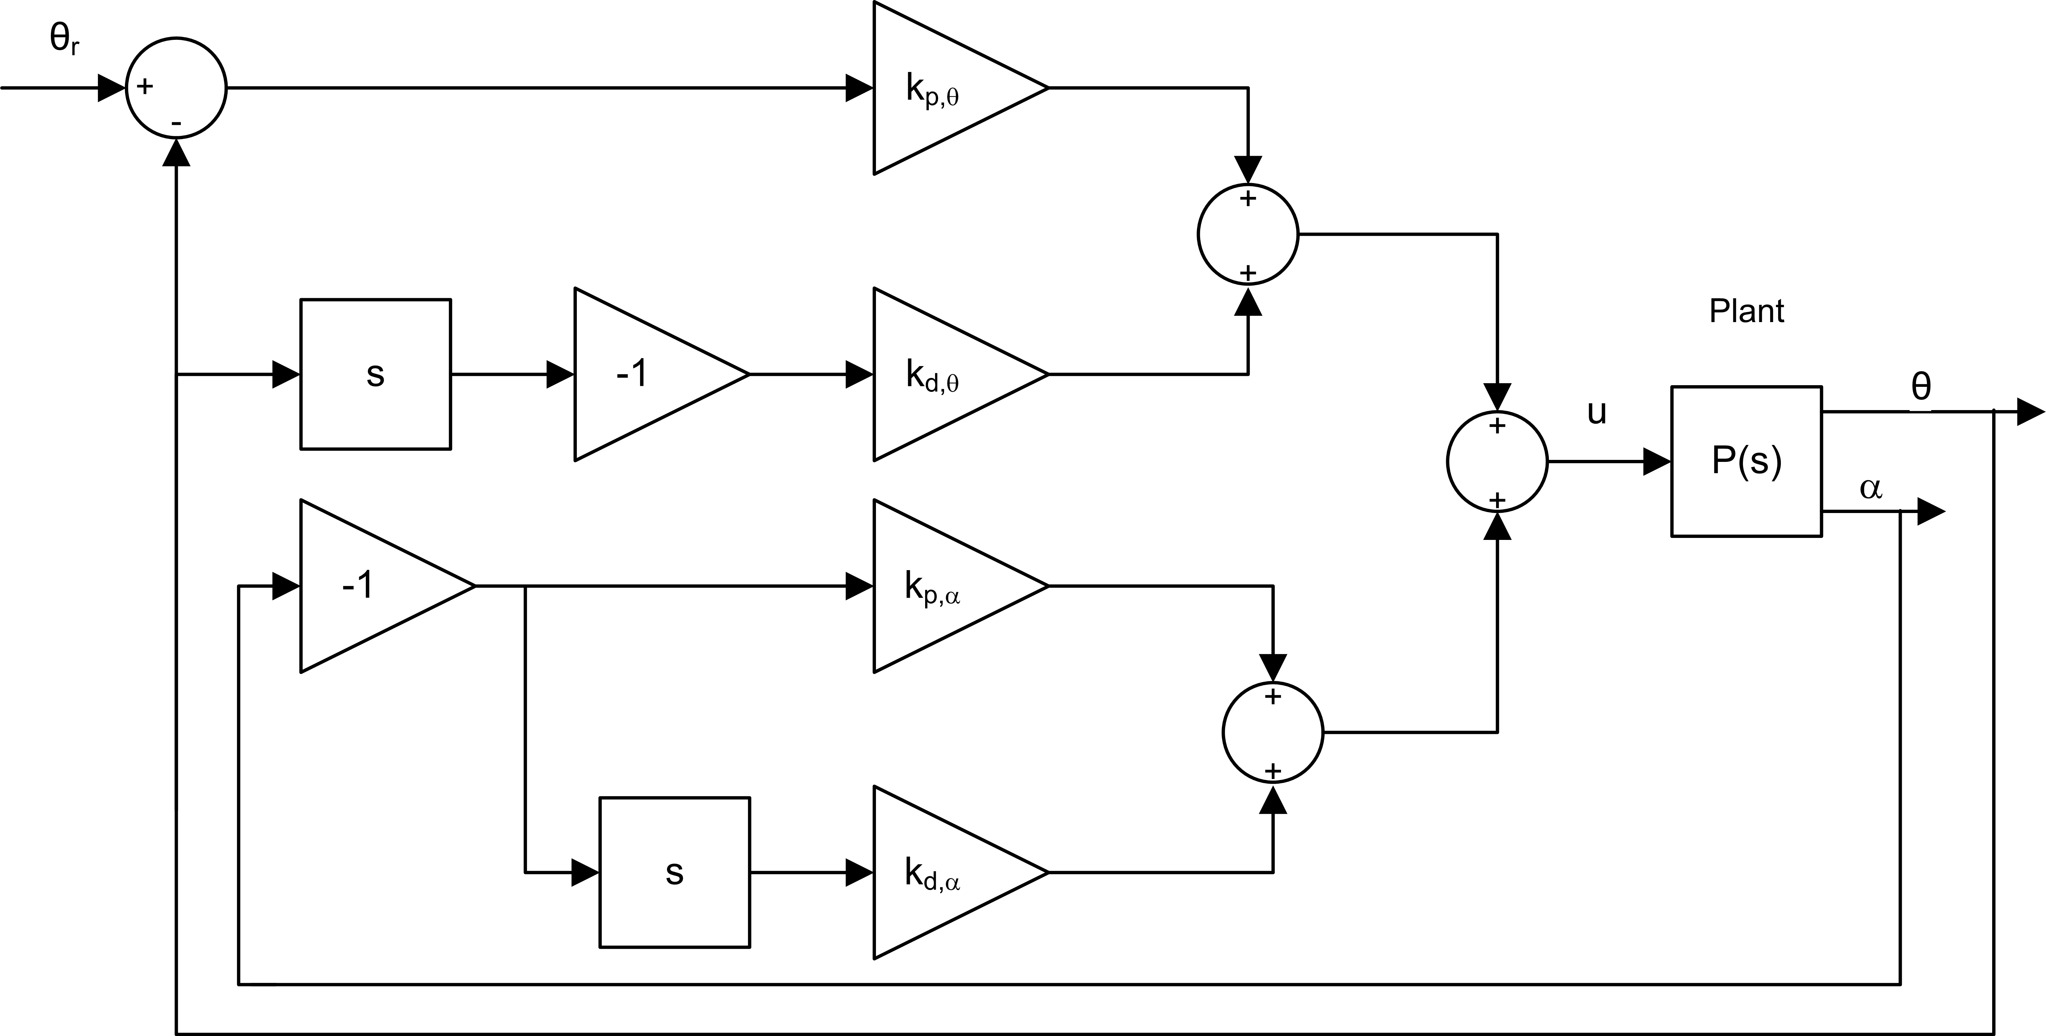

Figure 1.1: Block diagram of balance PD control for rotary pendulum

There are many different ways to find the controller parameters. One method is discussed in the Optimal LQR Control lab. Initially, however, the behavior of the system will be explored using default parameters.

Recall that the pendulum angle *α* is defined as zero when the pendulum is about its upright vertical position and expressed mathematically using *α* = *αf ull* mod2*π − π*, as defined in the Rotary Pendulum Modeling Lab as

*α* = (*αf ull* mod 2*π*) *− π.*

The balance control is to be enabled when the pendulum is within the following range:

*|α| ≤* 10*◦ .* (1.2)

Given that the pendulum starts in the downward vertical position, it needs to be manually brought up to its upright vertical position. Once the pendulum is within *±*10*◦* , the balance controller is engaged. It remains in balance mode until the pendulum goes beyond *±*10*◦* .

If desired, you can integrate this with an algorithm that swings-up the pendulum automatically. See the State Space

Modeling laboratory experiment for details.

**2 In-Lab Exercises**

Based on the VI developed in the Pendulum Moment of Inertia laboratory experiment, build a VI similar to that shown in Figure 2.1 that balances the pendulum on the QUBE-Servo 2 rotary pendulum using the PD control detailed in the background section of this lab.

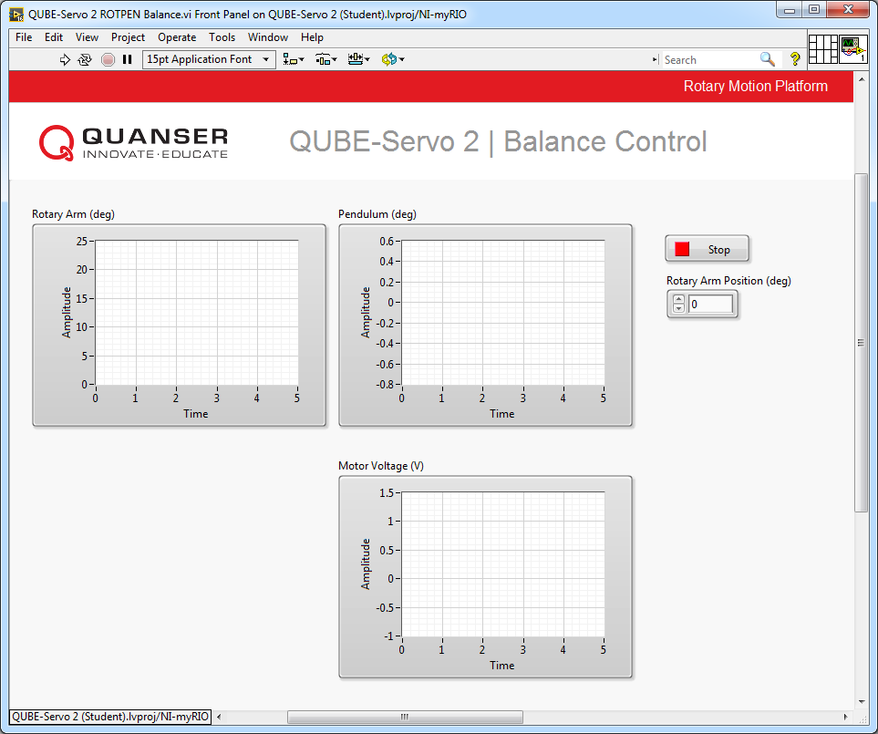

(a) Front Panel

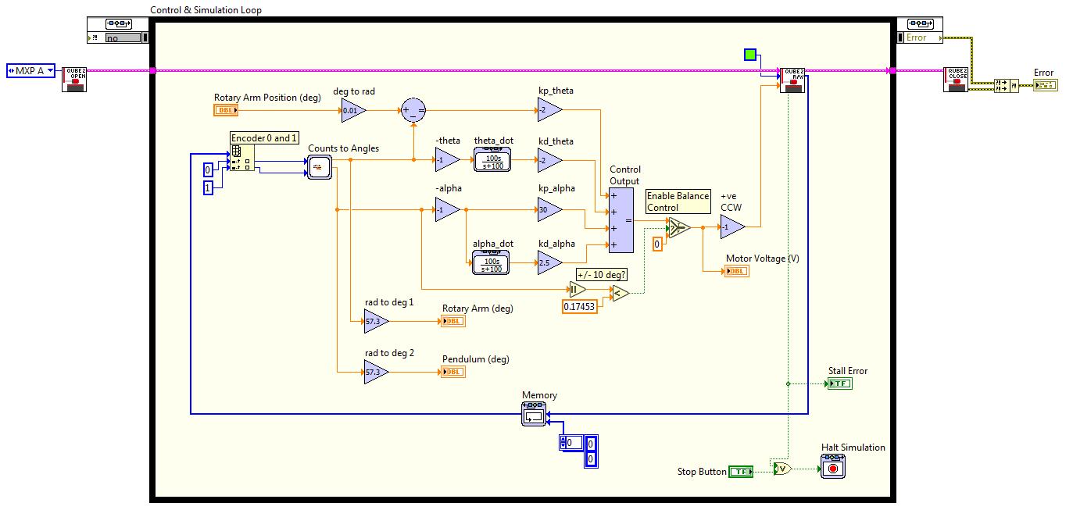

(b) Block Diagram

Figure 2.1: VI to run PD balance controller

1. Using the VI you made in the Pendulum Moment of Inertia laboratory experiment, construct the controller shown in Figure 2.1:

• The Counts to Angles subsystem contains the same blocks used in the Pendulum Moment of Inertia laboratory experiment to convert encoder counts to radians. Make sure you use the inverted pendulum angle.

• To find the velocity of the rotary arm and pendulum, add the high-pass filters 100*s*/(*s* + 100) similarly to the Filtering laboratory experiment.

• Add the necessary Sum and Gain blocks to implement the PD control given in Equation 1.1.

• The controller should only be enabled when the pendulum is *±*10*◦* about the upright vertical position (or

*±*0*.*175 rad). Add Absolute Value, Constant Comparison and Selector blocks to implement this.

2. Set the PD gains as follows: *kp,θ* = *−*2 V/rad, *kp,α* = 30 V/rad, *kd,θ* = *−*2 V/(rad/s), and *kd,α* = 2*.*5 V/(rad/s).

3. Make sure the pendulum is not perturbed in the downward position before starting the controller. Run the VI.

4. Manually rotate the pendulum in the upright position until the controller engages. The waveform charts should read something similar as shown in Figure 2.2. Attach response of the rotary arm, pendulum, and controller voltage.

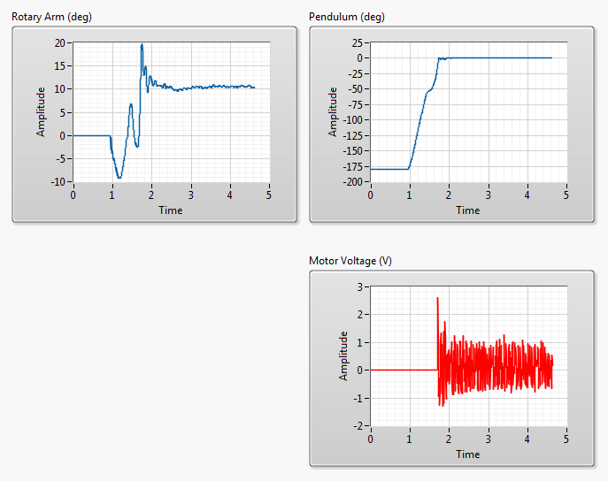

Figure 2.2: QUBE-Servo 2 rotary pendulum response

5. As the pendulum is being balanced, describe the responses in the *Rotary Arm (deg)* and the *Pendulum Angle*

*(deg)* waveform chart.

6. Locate the Summation block that precedes kp_theta. Vary the Constant block that is connected to the positive input of the Sum block. **Do not set the value too high, keep it within** *±*45 **to start**. Observe the response in the *Arm Angle (deg)* waveform chart. What variable does this represent in the balance control?

7. Click on the Stop button to stop the VI.

© 2017 Quanser Inc., All rights reserved.

Quanser Inc.

119 Spy Court Markham, Ontario L3R 5H6

Canada [info@quanser.com](mailto:info@quanser.com) Phone: 1-905-940-3575

Fax: 1-905-940-3576

Printed in Markham, Ontario.

For more information on the solutions Quanser Inc. offers, please visit the web site at:

[http://www.quanser.com](http://www.quanser.com/)

This document and the software described in it are provided subject to a license agreement. Neither the software nor this document may be used or copied except as specified under the terms of that license agreement. Quanser Inc. grants the following rights: a) The right to reproduce the work, to incorporate the work into one or more collections, and to reproduce the work as incorporated in the collections, b) to create and reproduce adaptations provided reasonable steps are taken to clearly identify the changes that were made to the original work, c) to distribute and publically perform the work including as incorporated in collections, and d) to distribute and publicly perform adaptations. The above rights may be exercised in all media and formats whether now known or hereafter devised. These rights are granted subject to and limited by the following restrictions: a) You may not exercise any of the rights granted to You in above in any manner that is primarily intended for or directed toward commercial advantage or private monetary compensation, and b) You must keep intact all copyright notices for the Work and provide the name Quanser Inc. for attribution. These restrictions may not be waved without express prior written permission of Quanser Inc.